**Student Name:** Tulasi Thanmai Channa

**Project Mentor:** Prof. Ganes Pandya

EZ Laundry

INVENTORY TRACKER



ABOUT THE COMPANY 3

WHAT IT DOES? 3

PROBLEM IDENTIFICATION & STATEMENT 3

ABSTRACT 4

OBJECTIVE 4

SCOPE OF PROJECT 4

DATABASE 5

TRANSACTIONS 6

POWER PIVOT 8

REPORTS 9

DYNAMIC CHARTS 11

HOME PAGE & DATA ENTRY 12

APP INTERFACE 13

PROJECT VIDEO 13

Table of Contents:

PROBLEM IDENTIFICATION & STATEMENT

The existing laundry service system lacks a detailed tracking mechanism beyond weight, date, and student's name. This gap hinders students from recalling exact quantities of clothes submitted, potentially leading to loss or misplacement. Additionally, without comprehensive tracking, inventory management, service optimization, and accurate billing become challenging. Therefore, implementing a more transparent system to capture quantity and types of clothes for each student is crucial for enhancing accountability, customer satisfaction, and operational efficiency.

.”

WHAT IT DOES?

EZ Laundry Services provides a wide range of laundry solutions, including machine and hand wash, ironing, and dry cleaning, ensuring customer satisfaction through quality and timely delivery. With transparent terms and a commitment to excellence, we remain the top choice for college students in Bangalore seeking reliable laundry services.

.”

ABOUT THE COMPANY:

Founded in 2018, EZ Laundry Services is a leading laundry provider for college students in Bangalore. With outlets strategically located in institutions like IFIM and ISBR, we offer efficient and transparent laundry solutions. Managed by a dedicated family team, we operate seven days a week, ensuring prompt and quality services, with clothes returned washed, ironed, and well-maintained within a day or two.



SCOPE OF PROJECT

The project aims to develop a user-friendly application using open-source software (Open Sapp) integrated with an Excel spreadsheet. The application facilitates efficient tracking of laundry items by enabling laundry representatives to record student names, submission dates, quantities, and total weights of clothes.

.”

OBJECTIVE:

“We get to understand the details collected during the collection of items and segregate the details required in the application. Then create an excel sheet of the details and use it while creating the openasapp application, providing all the functions required according to the laundry service provider.”

ABSTRACT:

“EZ Laundry is a laundry service present in multiple colleges across Bangalore. They have an outlet present in IFIM institutions. The laundry service is open on all days of the week and students receive their washed and ironed clothes after a day or two of service. Due to the demand for the service, they also maintain terms & conditions for complete transparency”

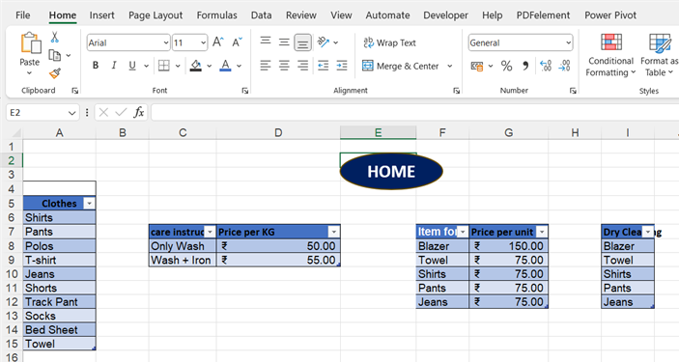

We have four tables in the database worksheet, each with the information of an organized database catering to a wide range of apparel goods. Everyday staples such as Shirts, Pants, Polos, T-shirts, Jeans, Shorts, Track Pants, Socks, Bed Sheets and Towels are available, as are more sophisticated products such as Blazers and Suits. There are extensive care instructions in the database, whether it's a basic machine wash, a wash followed by ironing, or specialized dry cleaning. Our care instructions are developed, and there are specifics on pricing per kilogram in the database.

The databases that are available are depicted in Exhibit 1.1.

**Exhibit 1.1**

DATABASE:

TRANSACTIONS:

1. **Customer Transaction Table**:
   * **Table Name:** customer transaction
   * **Columns:**
     + **Order_id**(Unique identifier for each order)
     + **Customer_name** (Name of the customer)
     + **Mobile_number** (Contact number of the customer)
     + **Care_instructions** (Instructions for garment care: wash, wash + iron, dry cleaning)

**2. Order Transaction Table**:

**Table Name:** Order_transaction

* + **Columns:**
    - **Order_id** (Unique identifier for each order, linking to customer_transaction)
    - **Pickup_date** (Date when the order is picked up)
    - **Return_date** (Date when the order is expected to be returned)
    - **Care_instructions** (Additional instructions for garment care, if any)

1. **Items Transactions Table**:
   * **Table Name:** Items_transactions
   * **Columns:**
     + **Order_id** (Unique identifier for each order, linking to customer_transaction)
     + **Care_instructions** (Garment care instructions for individual items in the order)
     + **Units** (Number of units of each garment type)
     + **Garments** (Type of garments in the order, e.g., shirts, trousers, etc.)
     + **Total bill amount** (The total bill amount you get for transactions)
2. **Payment Transactions Table**:
   * **Table Name:** Payment_transactions
   * **Columns:**
     + **Order_id** (Unique identifier for each order, linking to customer_transaction)
     + **Units** (Number of units in the order)
     + **Care_instructions** (Garment care instructions for this specific payment transaction)
     + **Payment_method** (Method of payment, e.g., credit card, cash, etc.)
     + **Weight** (Total weight of the laundry order)
     + **Amount_paid** (Amount paid for the order)
     + **Amount_to_be_paid** (Remaining amount to be paid)

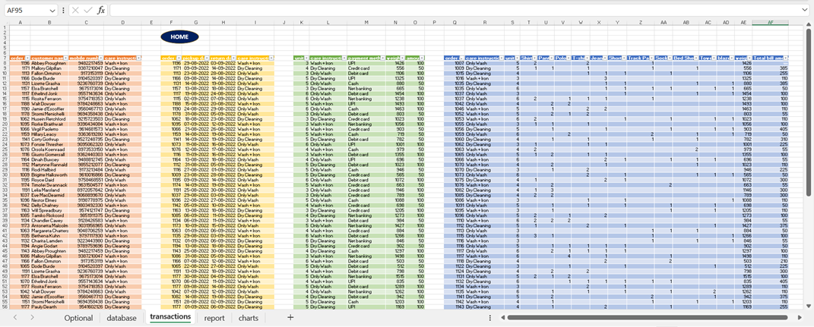

Power Pivot is an Excel add-in you can use to perform powerful data analysis and create sophisticated data models. With Power Pivot, you can mash up large volumes of data from various sources, perform information analysis rapidly, and share insights easily.

The below Exhibit 3.1 demonstrates the relationships formed between the database and transactions that share a single column, namely care instructions.

The database table names are displayed by the term table_db, which stands for database.

The table names of transactions are displayed by the term table_tr, which stands for transactions.

The care instructions and order id columns connect these tables, allowing you to link customer information, order data, payment records, and item-specific care instructions to each individual order.

This transaction structure makes it possible to manage laundry service transactions and client orders efficiently.

Exhibit 2.1 depicts the transactions involved in the project.

**Exhibit 2.1**

POWER PIVOT:

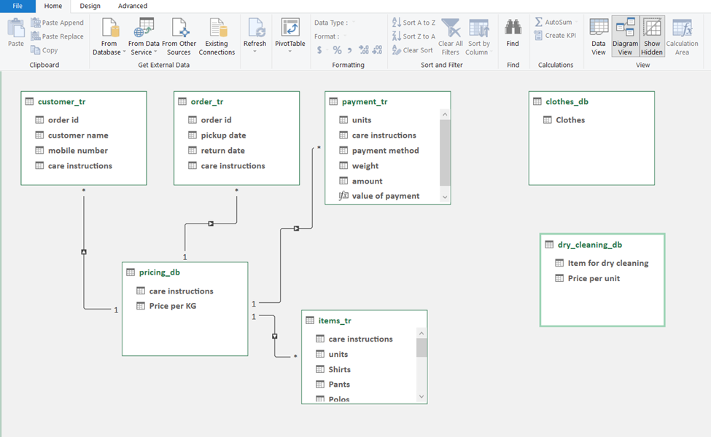

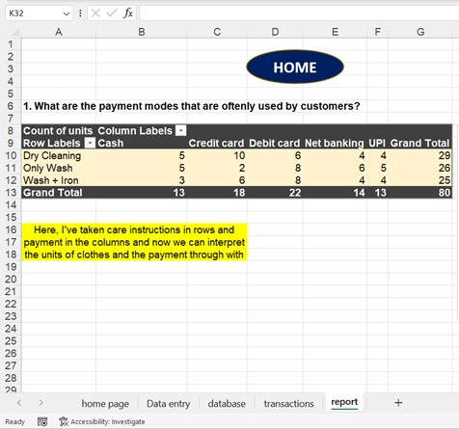

Reports are essentially interpretations that we make from analysis done utilizing dynamic charts, power pivot, tables, charts, and qualitative analysis to assist us get insights from raw data. Reports must be both useful and readable. I created four reports or questions and answers based on my database and transactions.

**Exhibit 4.1**

**Exhibit 3.1**

**Q1. What payment methods do customers use?**

A. It assists us in comprehending the payment mode so that the laundry business may make that payment option more straightforward and accessible to clients.

According to exhibit 4.1, there are more clients who use dry cleaning, and the customers use debit cards more frequently.

As a result, ezlaundry may acquire more swiping machines to facilitate payment process.

REPORT:

**Q2. How much inventory is currently at the ezlaundry?**

A. It changes the inventory or merchandise that is available for service automatically. They currently have 188 garnments on which to perform their service. It aids in the reduction of inventory loss, which can lead to increased customer satisfaction.

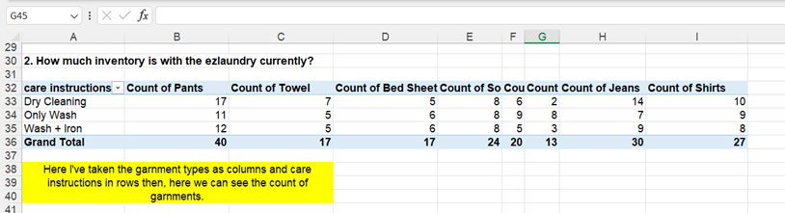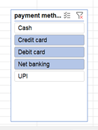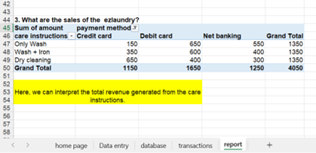

**Q4. Which orders must be done immediately?**

**A.** Here, we can see the orders that have to be done immediately. It is done by sorting and filtering by color.

To get this output, first use sort by ascending order for the return date.

Then, apply condition formatting to bottom 10 and apply custom formatting where we get the first 10 orders to be done in red color.

Filter it by color to get the output.

**Exhibit 4.4**

**Exhibit 4.3**

**Q3. What are the ezlaundry's sales (in dollars)?**

A. On this date, they generated 4050/- via credit card, debit card, and internet banking. We have payment methods available on the slicer.

We may check to see whether any sales were made using a certain payment method.

**Exhibit 4.2**

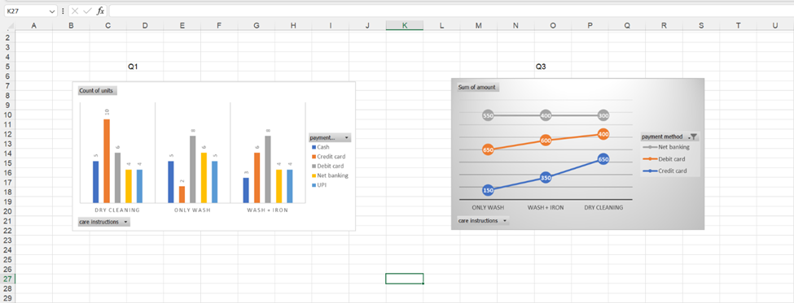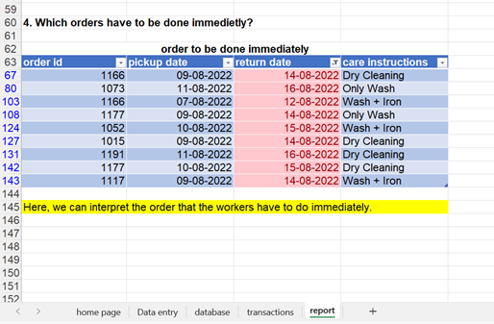

These are the charts associated with report questions 1–3. We can change from the grey icons near the legends if we require additional interaction and customization.

**Exhibit 5.1**

A dynamic chart is a special chart in Excel which updates itself when the range of the chart is updated. In static charts, the chart does not change itself when the range is updated.

DYNAMIC CHARTS

**Exhibit 4.5**

HOME PAGE & DATA ENTRY

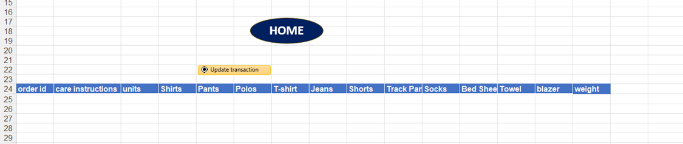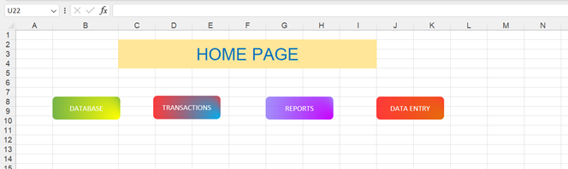

**Exhibit 6.2**

**DATA ENTRY:**

This is a tool that is designed in such a way that if there is a new order, enter the information in row 25 and click update transaction. The data will now be delivered to items tr and the charts, pivot table updates itself.

**Exhibit 6.1**

**HOME PAGE:**

This option enables you to return to the worksheet and the home page by one click on the buttons available on home page.

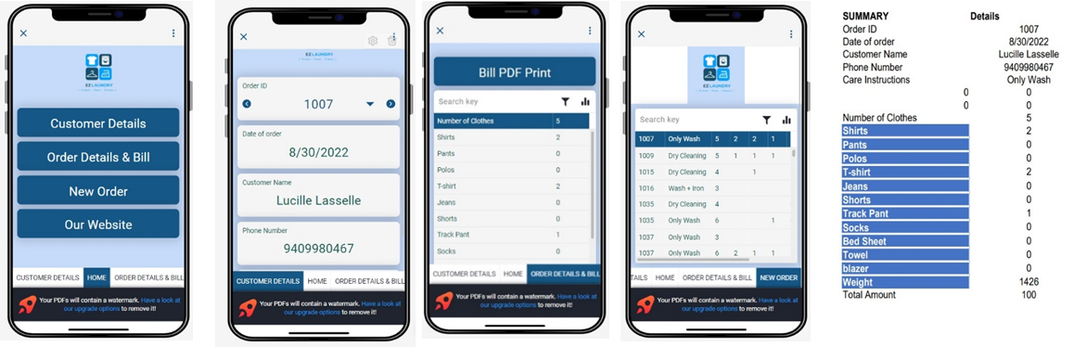

PROJECT VIDEO:

Define and describe what is the topic of the tentative video.

The application video is about the laundry management system which demonstrates how to use the application and the benefits of using the application.

APP INTERFACE:

The below images are the interface of the app and the last picture is when you click Bill PDF, you will get a PDF to print for bill.